Project Design Phase-II
Data Flow Diagram & User Stories
Date | 19 july 2026
Team ID
Project Name | SHOPEZ: E-Commerce Application
Maximum Marks | 4 Marks

Data Flow Diagram (Level-0)
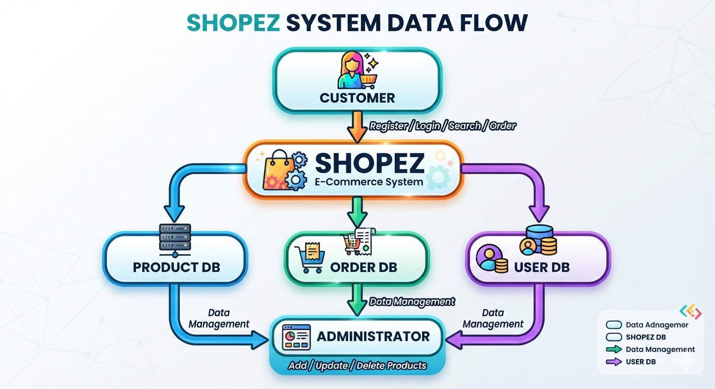
User Stories
User Type | Functional Requirement (Epic) | User Story No. | User Story / Task | Acceptance Criteria | Priority | Release
Customer (Web User) | Registration | USN-1 | As a customer, I can register using my name, email, and password. | Account is created successfully. | High | Sprint-1
Customer (Web User) | Login | USN-2 | As a customer, I can log in using my email and password. | User is redirected to the dashboard. | High | Sprint-1
Customer (Web User) | Browse Products | USN-3 | As a customer, I can view all available products. | Products are displayed correctly. | High | Sprint-1
Customer (Web User) | Search Products | USN-4 | As a customer, I can search products by name or category. | Relevant products are displayed. | High | Sprint-1
Customer (Web User) | Product Details | USN-5 | As a customer, I can view product details before purchasing. | Product information is displayed. | High | Sprint-1
Customer (Web User) | Shopping Cart | USN-6 | As a customer, I can add products to my cart. | Selected products appear in the cart. | High | Sprint-1
Customer (Web User) | Cart Management | USN-7 | As a customer, I can update or remove items from my cart. | Cart updates successfully. | High | Sprint-1
Customer (Web User) | Checkout | USN-8 | As a customer, I can place an order. | Order is stored successfully. | High | Sprint-2
Customer (Web User) | Order History | USN-9 | As a customer, I can view my previous orders. | Order history is displayed. | Medium | Sprint-2
Customer (Web User) | Wishlist | USN-10 | As a customer, I can save products to my wishlist. | Wishlist is updated successfully. | Medium | Sprint-2
Administrator | Product Management | USN-11 | As an admin, I can add new products. | Product is added to the database. | High | Sprint-1
Administrator | Product Management | USN-12 | As an admin, I can edit product details. | Product information is updated. | High | Sprint-1
Administrator | Product Management | USN-13 | As an admin, I can delete products. | Product is removed successfully. | High | Sprint-1
Administrator | Category Management | USN-14 | As an admin, I can manage product categories. | Categories are updated successfully. | Medium | Sprint-2
Administrator | Order Management | USN-15 | As an admin, I can view and manage customer orders. | Order status can be updated. | High | Sprint-2
Administrator | User Management | USN-16 | As an admin, I can view registered users. | User list is displayed. | Medium | Sprint-2
Customer Care Executive | Customer Support | USN-17 | As a support executive, I can respond to customer queries. | Customer issues are resolved. | Medium | Sprint-2
Customer Care Executive | Order Assistance | USN-18 | As a support executive, I can assist customers with order status. | Order information is provided correctly. | Medium | Sprint-2

